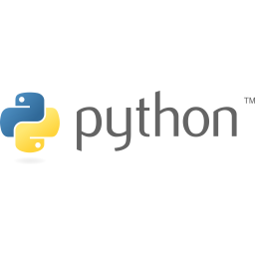

|  |
| --- |
| Close-up image showing the leaf-sides of two oversized books side-by-side on a bookshelf, with additional books in soft focus background |
| Python Exercises 1  Networkwalks Academy |
| |  |  |  | | --- | --- | --- | | Cisco Certifications | www.networkwalks.com | info@networkwalks.com | |



**Python Exercises**

**(part 1)**

1. **Write a program in Python which asks you to input any number of hours & converts it into seconds?**

**SOLUTION:**

**hours = int(input("Enter the number of hours: "))**

**seconds = hours * 360**

**print(seconds)**

1. **Write a program in Python which asks you to input two numbers & returns the sum of them?**

**SOLUTION:**

**number_1 = int(input("Enter the first number to add: "))**

**number_2 = int(input("Enter the second number to add: "))**

**addition = number_1 + number_2**

**print(addition)**

1. **Write a program in Python that asks you to enter two numbers, compares them & tells you which of them is bigger or both are equal?**

**SOLUTION:**

**number_1 = int(input("Enter the first number to add: "))**

**number_2 = int(input("Enter the second number to add: "))**

**bigger_number = number_1**

**if number_2 == bigger_number:**

**print("These numbers are equal: ")**

**elif number_2 > bigger_number:**

**bigger_number = number_2**

**print("The biggest number is: ", bigger_number)**

**else:**

**print("The biggest number is: ", bigger_number)**

1. **Write a program in Python that asks you to enter a text string & returns string 'a' replaced with ' 0' *(for example, networkwalks should be returned as networkw0lks)***

**SOLUTION:**

***word = input("Enter a word: ")***

***new_word = ''***

***for letter in word:***

***if letter == 'a':***

***new_word += ('0')***

***continue***

***else:***

***new_word += letter***

***print(new_word)***

1. **Write a program in Python that asks you to enter a text string & tells you its length?**

**SOLUTION:**

**word = input("Enter a word to determine its length: ")**

**print(len(word))**

1. **Write a program in Python that will produce following output using For loop:**

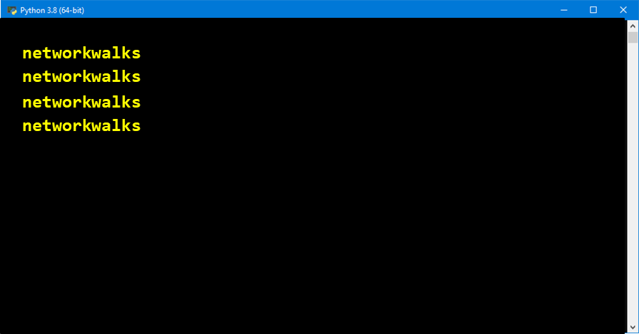

**SOLUTION:**

**for i in range(4):**

**print("networkwalks")**

1. **Write a program in Python that will produce following output using While loop:**



**SOLUTION:**

**i = 0**

**while i <= 3:**

**print("networkwalks")**

**i += 1**

1. **Write a program in Python which asks you to input two numbers & returns the average of them?**

**SOLUTION:**

**number_1 = int(input("Enter the first number to add: "))**

**number_2 = int(input("Enter the second number to add: "))**

**average = (number_1 + number_2)/2**

**print(average)**

1. **Write a program in Python that will produce following output:**

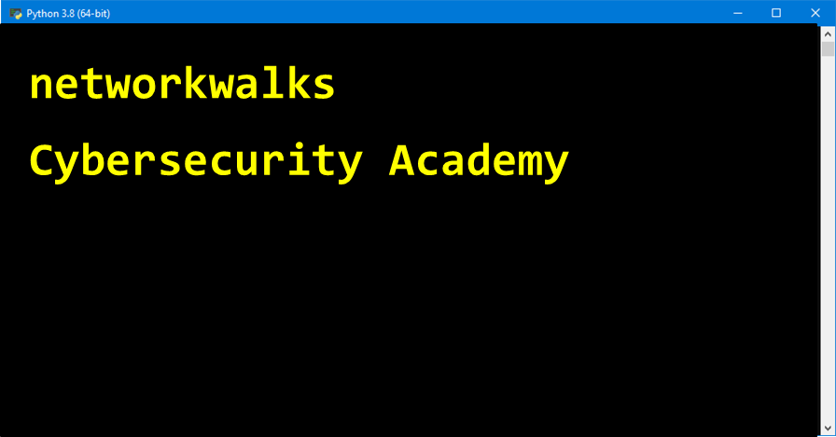

**SOLUTION:**

**print("networkwalks")**

**print("cybersecurity Academy")**

1. **What will be the output of following Python code?**

**var1 = 1**

**var2 = 2**

**var3 = "3"**

**print(var1 + var2 + var3)**

**SOLUTION:**

**It will generate an error because a string cannot be added to an integer.**

1. **What will be the output of following Python code?**

**var1 = 1**

**var2 = 2**

**var3 = "3"**

**print(var1, var2, var3)**

**SOLUTION:**

**1, 2, 3**

1. **What will be the output of following Python code?**

**a = 3 + 2 * 4 + 4**

**print(a)**

**SOLUTION:**

**15**

1. **What will be the output of following Python code?**

**x = 8 + 8 * 9**

**print(x)**

**SOLUTION:**

**80**

1. **What will be the output of following Python code?**

**i = 8 + 8 * 9 + 9 (10-9)**

**print(i)**

**SOLUTION:**

**It will generate an error. To multiply a number, one shoud use the asterisk * sign, not brackets. Python will treat 9(10-9) as a function call.**

1. **What will be the output of the following Python code?**

**p, q, r = 10, 20 ,30**

**print(p, q, r)**

**SOLUTION:**

**10, 20, 30**

1. **Write a program in Python, using For loop, that asks you to enter a text string & then prints its letters separately?**

**SOLUTION:**

**word = input("Enter a word")**

**for i in word:**

**print(i)**

1. **Write a program in Python that will produce following output using only one Print function command (do not use print function more than once, do no use loop or other functions):**

*

* *

* *

* *

*** ***

* *

* *

*****

***\*Hint:*** *Use Print function & \n in a single line command.*

**SOLUTION:**

print(""" *

* *

* *

* *

*** ***

* *

* *

*****""")

1. **Write a program in Python that will produce following output using 8x Print function commands (use print function eight times, do no use loop or other functions):**

*

* *

* *

* *

*** ***

* *

* *

*****

**SOLUTION:**

**print(" * ")**

**print(" * * ")**

**print(" * * ")**

**print(" * * ")**

**print("*** ***")**

**print(" * * ")**

**print(" * * ")**

**print(" ***** ")**

1. **Write a program in Python that will produce following output using for Loop:**

*

* *

* * *

***Hint:*** *Use nested for loop (for loop inside another for loop)*

**SOLUTION:**

star = "* "

for i in range(1,4):

print(star)

star += "* "

1. **Write a program in Python that will produce following output using for Loop:**

*

* *

* * *

* * * *

* * * * *

***Hint:*** *Use nested for loop (for loop inside another for loop)*

**SOLUTION:**

star = "* "

for i in range(1,6):

print(star)

star += "* "



© All Rights are reserved, Network Walks Academy

Leave your feedback at: [info@networkwalks.com](mailto:info@networkwalks.com). Your Technical Questions, comments & suggestions are always Welcomed.

www.networkwalks.com